SMART GARBAGE DUSTBIN

(BINOLOGY)

**MURALIDHARAN M1, JOHN MARTIN A2**

1Department of MCA, Sacred Heart College, Tirupattur

2Deparment of MCA, Sacred Heart College, Tirupattur

Email: [muralidharantpt18@gmail.com1](mailto:muralidharantpt18@gmail.com1), [martin@shctpt.edu](mailto:martin@shctpt.edu2)[2](mailto:martin@shctpt.edu2)

***Abstract***

***This project smart garbage dustbin system is a very innovative smart system which will help us to keep our cities and surroundings clean. In several urban areas even the dustbins are provided but those dustbins are without proper maintenance of waste which may cause lots of virus and environment contamination and also destroying our location day by day also ensuing severe adverse effects for mankind. In the habitual system, the garbage uses to be collected in a manual way. So that time is extreme. This project which can reduce their time and shot in professional manner. mechanization is the most demandable feature now a day. For this purpose, smart dustbins are the much suitable move towards. It will be useful to build up green and smart city. For this we have to build up an automatic smart dustbin which will first be able to sense the present status of the garbage bin send the information to the garbage gathering vehicle employee. They can straight away take action to empty. It crucial helps to keep neatness in the society and hence the increase of diseases caused by waste objects are reduces.***

**Keywords: -smart garbage waste bin, microcontroller, monitoring, sensors, vending machine.**

Sensor1

**1. Introduction**

Sensor 2

This keen container is a creative framework which will assist with keeping the urban areas clean. This plan screens the trash containers and educates about the degree of trash collect in the trash canisters. For this the plan utilizes ultrasonic sensors set over the containers to see the trash level and measure dependent upon it with the trash canisters profundity.

Motor

It will spoil the atmosphere day by day to cause the many types of pollution along with to create many diseases for human and other animals also. We arranged shrewd dustbin framework which will screen and alarm when the trash level crosses the section level of the trash receptacle. This interaction will be endorsed out with the assistance of sensors, ATMEGA16 and ESP8266.Now days in the majority cities there are many dustbins which are in horrific conditions. The garbage in dustbins all overflowed of the dustbin. Many people are throwing garbage on that dustbin which are already full or overflowed. Due to this unclean of garbage bins pollution is increases which are bad for the environment. This creates a very bad look of the city which is a way to support to the air pollution and to some injurious diseases which are easily spreadable. For this we have to develop an automatic dustbin which will detect the garbage is dry or wet then separate the garbage and informs about the level of garbage collected in the garbage bin to a person in the garbage collecting vehicle and by using retailing machine coins comes out the smart dustbin. This arrangement helps to city clean and green.

Wi-Fi Module

Dustbin

Motor

Vending mahine

Power Suply +5V

Fig1.1(Connection Model)

**3. Writing Survey:**

A Smart Waste Bin for Smart Waste affiliation proposed in this paper, the structure contains sensors to measure the store of The investigator suggest the procedure for rubbish the chiefs which is as follows. The LCD screen is utilized to show the situation with the degree of trash made in the canisters. Where as GSM is worked waste and the degree of waste inside the canister. Bluetooth is added for short show up at statement.. The examiners suggest the procedure for waste the board which is according to the accompanying. In this paper the compartment was connected with a microcontroller-based construction which had IR distant framework with a key focal plan that shows the current status of the trash canister. The status was seen on a minimal based web program with html page by utilizing Wi-Fi. In this framework to diminish the expense they utilized weight sensor and on the sender's side they utilized a Wi-Fi module to send and get the information. In the end the weight sensor so to talk perceives the heap of the garbage in the holder yet not the stature of waste

.**4. Proposed framework:** This paper proposing new trash gathering approach to sort out the loss by utilizing the assistance of these sensors' the framework can get data about the receptacle is over bending by the grouping given by sensor then they can undoubtedly discover the container where situated and squash it as early conceivable. At the point when trash toss in dustbin. Engine pivot concurring sensor and afterward wet and dry trash is taken out. A transport line turns and comes out coins.

**5. Equipment:-**

**5.1. HC - SR04 Ultrasonic Sensor: -**

This sensor is an uncommonly recognized sensor used in various applications where assessing space or identifying objects are need. The Ultrasonic transmitter sends a ultrasonic wave, this sign goes in air and when it gets fought by any material it gets reflected back toward the sensor this reflected wave is practical by the Ultrasonic beneficiary module as shown in the picture underneath. The Electric Parameter Working Voltageis Direct Current-5V, Working Current - 15mA, Working Frequency - 40Hz, Max Range - 4meter, Min Range-2cm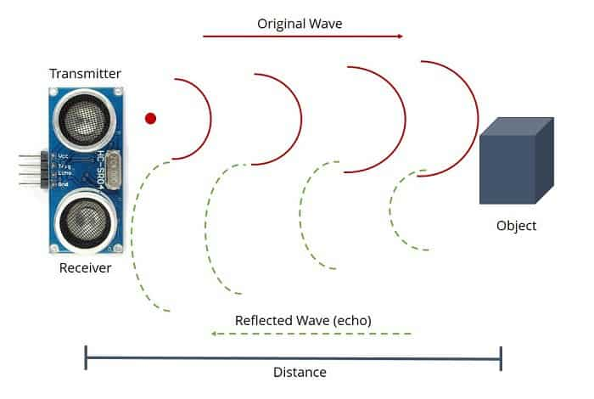

Fig 1.2(ultrasonic sensor)

**5.2. ATMEGA 16:** - In this undertaking ATMEGA 16 microcontroller is utilized for oversee framework. It gets data from sensors and technique on it and contrasts the showing up information and the section level set and thusly yield is produced.

**5.3. Wi-Fi module: -** ESP8266 is a Wi-Fi module which will offer your activities right of passage to Wi-Fi or web. It might banter with any microcontroller and make the undertakings remote. The ESP8266 has 8 pins; the Receptacle ULTRASONIC SENSOR1 SENSOR 2 MOTOR(100PRM) MOTOR(100P RM) WI-FI MODULE Candy machine Force SUPLY VCC and CH-PD will be associated with the 3.3V to empower the Wi-Fi. This is worn for execution.

**5.4. Force supply +5v:** - Just in addition to five voltage direct current force supply is required for this venture. Force supply is needed to work the opening framework and +12 v utilized for engine.

**5.5. Engine for Separator : -** Engine separator is utilized to Separation of trash. At the point when trash is wet it will pivot right side or dry it will turn left side. As per the circumstance engine pivoted hostile to clockwise or clockwise.

**5.6. Sensor (trash sensor):** - Sensor is utilized to identify the object(Garbage)level. On the off chance that the receptacle is full it will recognize the alert

**5.7. Transport line: -** Transport line is utilized to turn the engine, Either in the forward heading or reverse way.

**5.8. Engine (100 RPM):** - Engine is worn for turning of transport line.

**Different Components Used-**

5.1) Arduino

5.2)GSM

5.3) PIR Sensor

5.4) Ultrasonic Sensor

5.5) Servo Motor

5.6) Breadboard

5.7) Connecting wires

**5.1) Arduino-**

Arduino is an open source. Arduino sheets are existing monetarily in preassembled structure, or as DIY units. Arduino board plans utilize an assortment of focal processor and regulators. The sheets can with sets of electronic and fundamental information/yield (I/O) sticks that might be interfaced to an assortment of progress sheets and different circuits. The sheets highlight successive correspondences interfaces, recalling Universal Serial Bus for explicit models, which are also worn for stacking programs from PCs. Arduino Uno is a microcontroller board subject to the datasheet. It contains all that typical to hold the microcontroller;

**Force USB**-

Arduino board can be compelled by utilizing the USB associate beginning your PC. You ought to just join the USB associate with the USB connection

**Force (Barrel Jack)** –

Arduino sheets can be controlled straightforwardly from the AC mains power supply by interfacing it to the Barrel Jack.

**Voltage Regulator** –

The limitation of the voltage regulator is to plan the voltage given to the Arduino board and strong the DC voltages used by the processor and various rudiments.

**Significant stone Oscillator** –

The diamond oscillator used Arduino in managing time issues.Arduino Reset - we can reset our Arduino load up, for instance :begins our program from the beginning. we can reset the arduino board twoly. Regardless, by utilizing the reset button on the board. Second, we can relate an outer reset catch to the Arduino pin checked RESET

**GND:**

**Ground** – which is used to ground our circuit.

**Progressed I/O –**

The Arduino UNO board have fourteen modernized I/O pins (15) yield. These pins can be planned to function as information motorized pins to investigate thinking respects (0 or 1) or as forefront yield pins to drive various modules like LEDs, moves, and so forth The pins portrayed can be utilized to make PWM.

**AREF-**AREF is the abbreviated type of Analog Reference.

**5.2-GSM (Global System for Mobile Communication)-**

GSM Modem can allow any GSM network chairman SIM card and act a lot of like a cell with its own intriguing phone number. Advantage of using this modem will be that you can use its RS232 port to talk and cultivate embedded applications. Applications like SMS Control, data move, regulator and logging can be developed successfully using Global System for Mobile Communication. The modem can be related with PC consecutive port directly or to any microcontroller through MAX232. It might be used to send and get SMS or make/get voice calls.

**PIR Sensor:-**

PIR sensors permit us to detect movement. They are utilized to identify whether a human has invigorated in or out of the sensor's reach.

These are the upsides of PIR Sensors

* Little in size
* Wide focal point range
* Simple to interface
* Economical
* Low-power
* Simple to utilize
* Try not to wear out

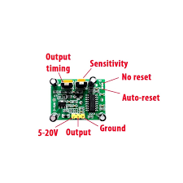

Fig1.3(PIR sensor)

PIRs is made, a round metal can with a rectangular gem in the middle, which can see the degrees of infrared discharge. The entire thing produces low-level radiation, and the more blazing something is, the extra radiation is discharged.

**5.4) ULTRASONIC SENSOR**

The ultrasonic sensor uses SONAR to choose the distance of an article really like the bats do. It offers outstanding non-contact range disclosure with high precision and stable readings in a basic touse group from 2 cm to 400 cm. The action isn't impacted by sunlight or dull material, whether or not acoustically, sensitive materials like texture can be difficult to recognize. It comes all out with ultrasonic transmitter and authority module.

**Specialized Specifications**

Force deliver − +5V DC

Working contemporary − 15mA

Effective position − <15°

Going expanse − 2cm – 400 cm/1″ – 13ft Resolution − 0.3 cm

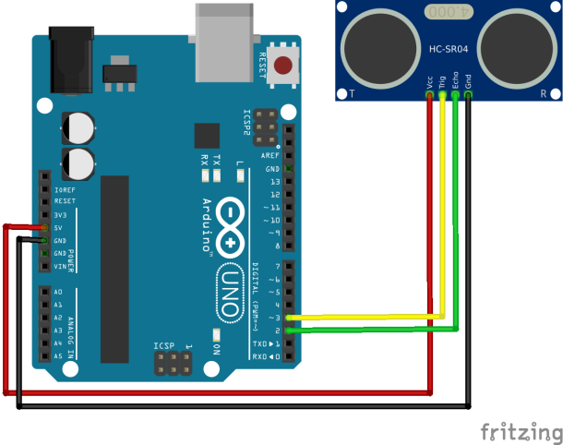

Fig1.4(Ultrasonic Sensor)

**5.5) Servo Motor-**

A Servo Motor is brief contraption that has a yield shaft. This shaft can be arranged to express saucy circumstances by passing on the servo a coded message. Anyway long the coded signal exists on the data line, the servo motor will keep up the sharp circumstance of the shaft. If the coded signal changes, the jaunty circumstance of the shaft changes. Before long, servo motors are used in radiocontrolled planes to arrange control surfaces like the lifts and rudders. They are moreover used in robots.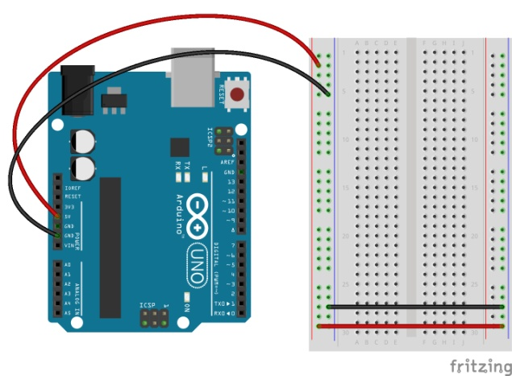

Fig 1.5(Breadboard)

**6. Partition of Wet and Dry Garbage: -**

When the waste materials are gathered at on place detachment of wet and dry trash is significant reusing and partition of wet and dry trash has consistently been challenge of civil strong waste administration and it has become a significant issue for governments everywhere on the world. In this meeting we mean to utilize engine (30 rpm) for distinguishing and isolating various sorts of trash. A transport line conveying coins when trash tosses in the dustbin at that point coins comes out from container.

**5.6) Breadboard-**

A breadboard is a progression base for prototyping of contraptions. From the start it was from a real viewpoint a bread board, a finished piece of wood utilized for cutting bread. Since the solderless breadboard needn't mess with confining, it is reusable. This works on it to use for making short lived models and endeavoring different things with circuit plan. Accordingly, solderless breadboards are also unbelievably standard with understudies and in mechanical direction. More pre-arranged breadboard types didn't have this property. A stripboard (Vero board) and identical prototyping printed circuit sheets, which are utilized to assemble semi-suffering fixed models or momentous cases, can just with basic effort be reused. An assortment of electronic constructions might be prototyped by utilizing breadboards, from negligible clear and advanced circuits to finish focal arranging units (CPUs).

Motor

Waste from bin

Conveyer Belt

Vending Machine

Separating Unit

Fig1.6(Separation Unit)

**7. Working: -**

This endeavor canny refuse dustbin is a creative system which will help with keeping the metropolitan regions clean. This structure screens the junk canisters and instructs about the level of waste accumulated in the refuse repositories. For this the structure uses ultrasonic sensors set over the holders to distinguish the refuse level and differentiation it and the rubbish canisters significance. The functioning project is taken care of into the ATMEGA 16. Ultrasonic sensor detects the trash even out and likewise convey the messages to the ATMEGA16. ATMEGA16 measure the got signal and passed further to the ESP8266. ESP8266 is a Wi-Fi module (center MCU) which is furthermore filling in as a transmitter in our structure. ESP8266 accepts indispensable part in decreasing the gear of the system. In this manner when trash passes the boundary level, site page shows the area of that canister by utilizing html. Sensor is utilized for detecting the trash whether it is dry or wet. Engine (30 RPM) is utilized for motivation behind Separation of trash. At the point when trash is wet or dry as per the circumstance engine turned enemy of clockwise or clockwise. Transport line utilizes a wide belt and pulleys and is upheld by engine. A transport line conveying coins/chocolates. Belt is turned with unending circle. At the point when trash tosses in the dustbin at that point coins/chocolates comes out from the dustbin. Engine (100 RPM) is utilized for turning of transport line.

**8. Demo model**

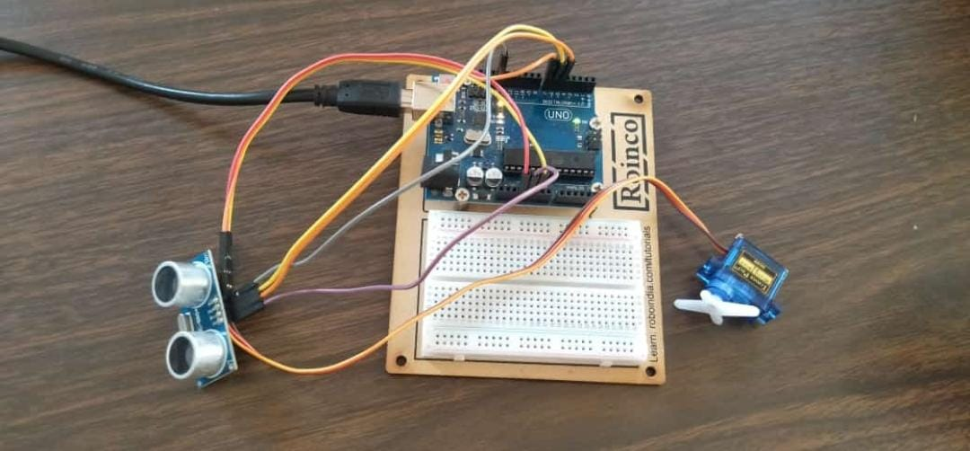

Fig1.7(Demo model)

**10 . PROPOSED APPLICATION**

* Waste Level location inside the trash containers. Transmission of the data remotely to concerned authorities .
* Real-time information transmission and access
* Avoids the floods of trash receptacles.
* Improves Environment quality-Fewer scents Cleaner urban communities

**11. Benefits**

* Real time information on the fill level of the dustbin.
* Deployment of dustbin reliant upon the certified prerequisites.
* Cost Reduction and resource upgrade.
* Improves Environment quality - Fewer aromas Cleaner metropolitan networks
* Effective utilization of dustbins

**12. FUTURE ENHANCEMENT**

* Smart dustbin assists us with decreasing the defilement.
* The message can be sent unmistakably to the cleaning vehicle rather than the expert for enroll's office

**13. Conclusion**

* This framework guarantees the cleaning of dustbins soon when the waste level appears at its for the most part silly
* If the dustbin isn't cleaned in unequivocal time, by then the record is passed on off the more huge position authority who can take a fitting action against the concerned undertaking specialist
* Therefore, the mind blowing deny the board structure makes the garbage assortment more helpful. Such constructions are feeble against attacking of segments in the framework in various ways which should be chipped away at

**Reference:**

1. <https://www.researchgate.net/publication/339301914_Iot_Based_Smart_Dustbin>
2. <https://en.wikipedia.org/wiki/Garbage_collection>
3. [http://www.arduino.cc](http://www.arduino.cc/)
4. <http://ijariie.com/AdminUploadPdf/A_REVIEW_ON_SMART_GARBAGE_DUSTBIN_ijariie9511.pdf>
5. IJSRD - International Journal for Scientific Research & Development| Vol. 5, Issue 01, 2017 | ISSN (online): 2321-0613 IoT Based Garbage Monitoring System. Puspendra Singh, Ram Bilas Nagar, Ranjeet Kumar Raman, Rishikesh Kumar Gupta, Rupal Gupta
6. International Journal of Advanced Research in Computer and Communication Engineering ISO 3297:2007 Certified Vol. 7, Issue 4, April 2018 Copyright to IJARCCE DOI 10.17148/IJARCCE.2018.7434 177 GSM based Garbage Monitoring System S.Kale, P.Alane, K. Gaikwad